FR. CONCEICAO RODRIGUES COLLEGE OF ENGINEERING

Department of Computer Engineering

# Course, Subject & Experiment Details

|  |  |
| --- | --- |
| Practical No: |  |
| Title: | To study and Implement Database as a Service on SQL/NOSQL databases like AWS RDS, AZURE SQL/ MongoDB Lab/ Firebase. |
| Name of the Student: | Warren Fernandes |
| Roll No: | 8940 |
| Date of Performance: | 11/04/2022 |
| Date of Submission: | 11/04/2022 |

Evaluation:

|  |  |  |
| --- | --- | --- |
| Sr. No. | Rubric | Grade |
| 1 | On time submission/completion (2) |  |
| 2 | Preparedness (2) |  |
| 3 | Skill (4) |  |
| 4 | Output (2) |  |

Signature of the Teacher

1. Connect to AWS RDS

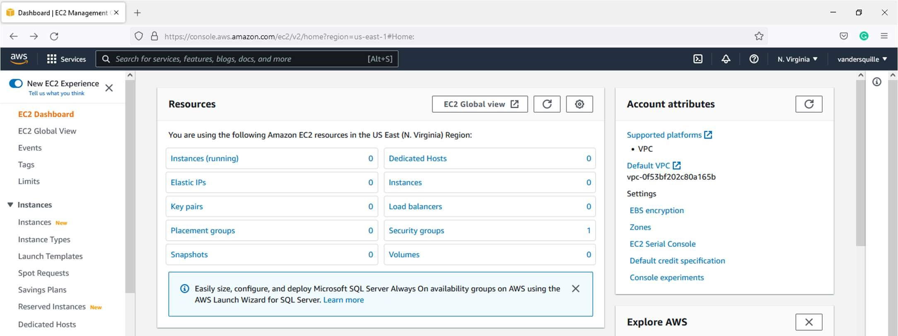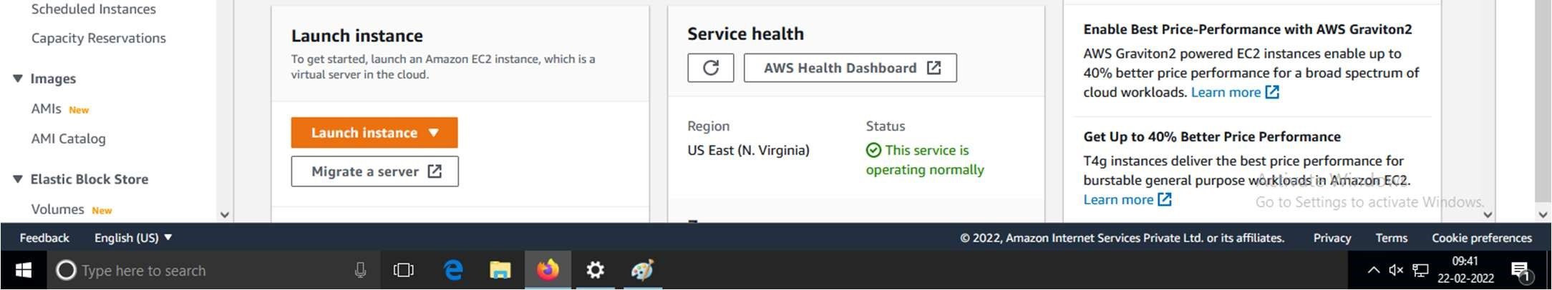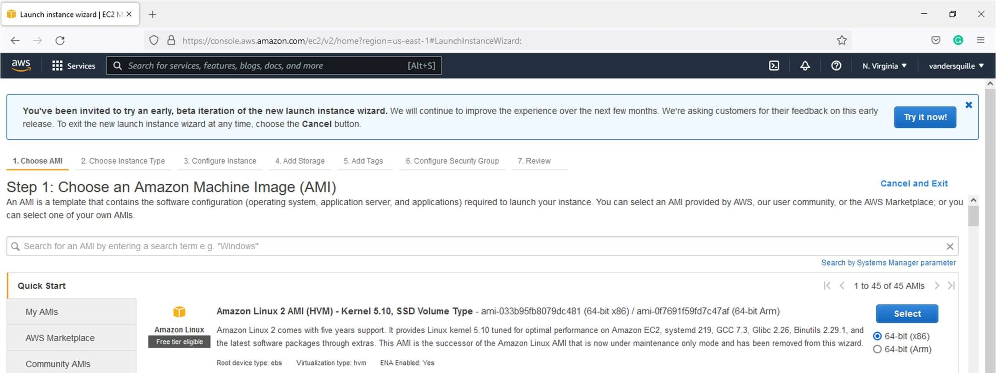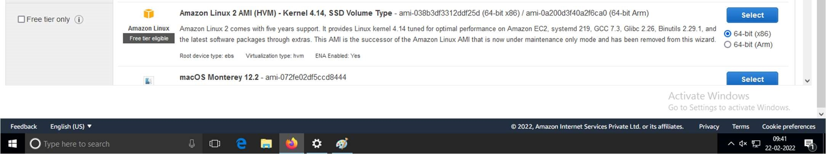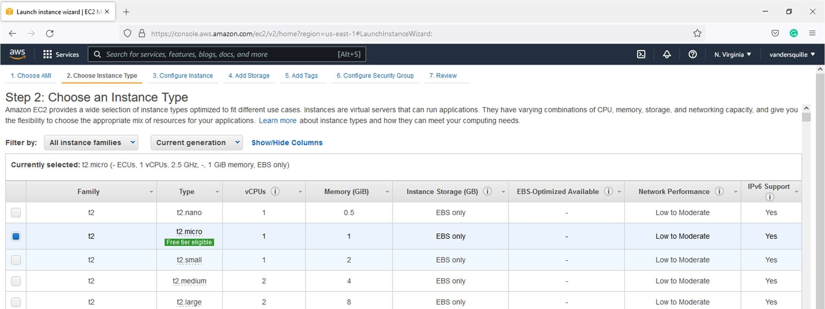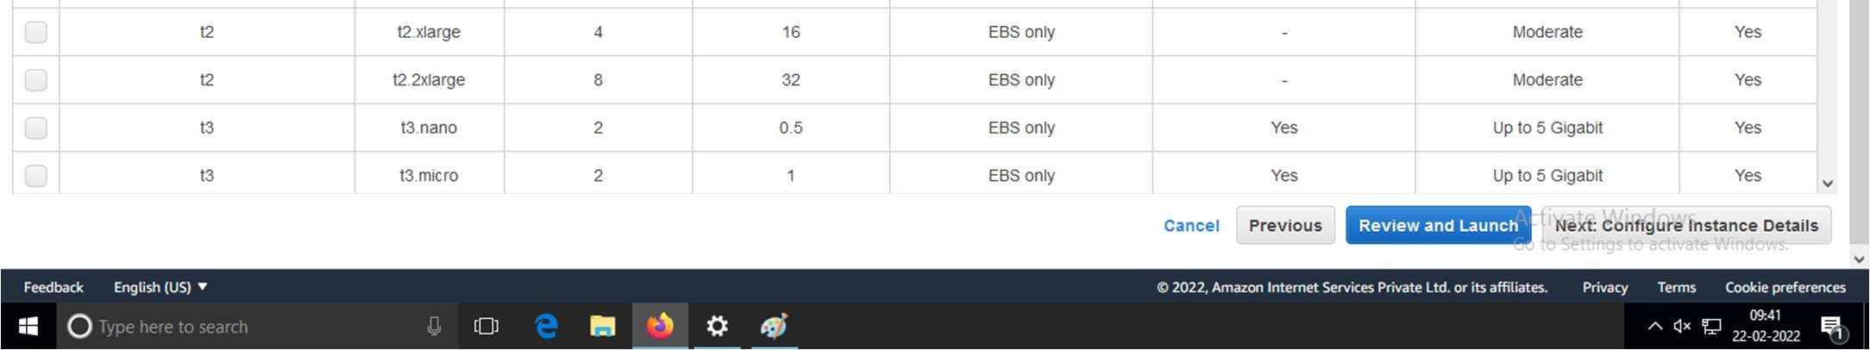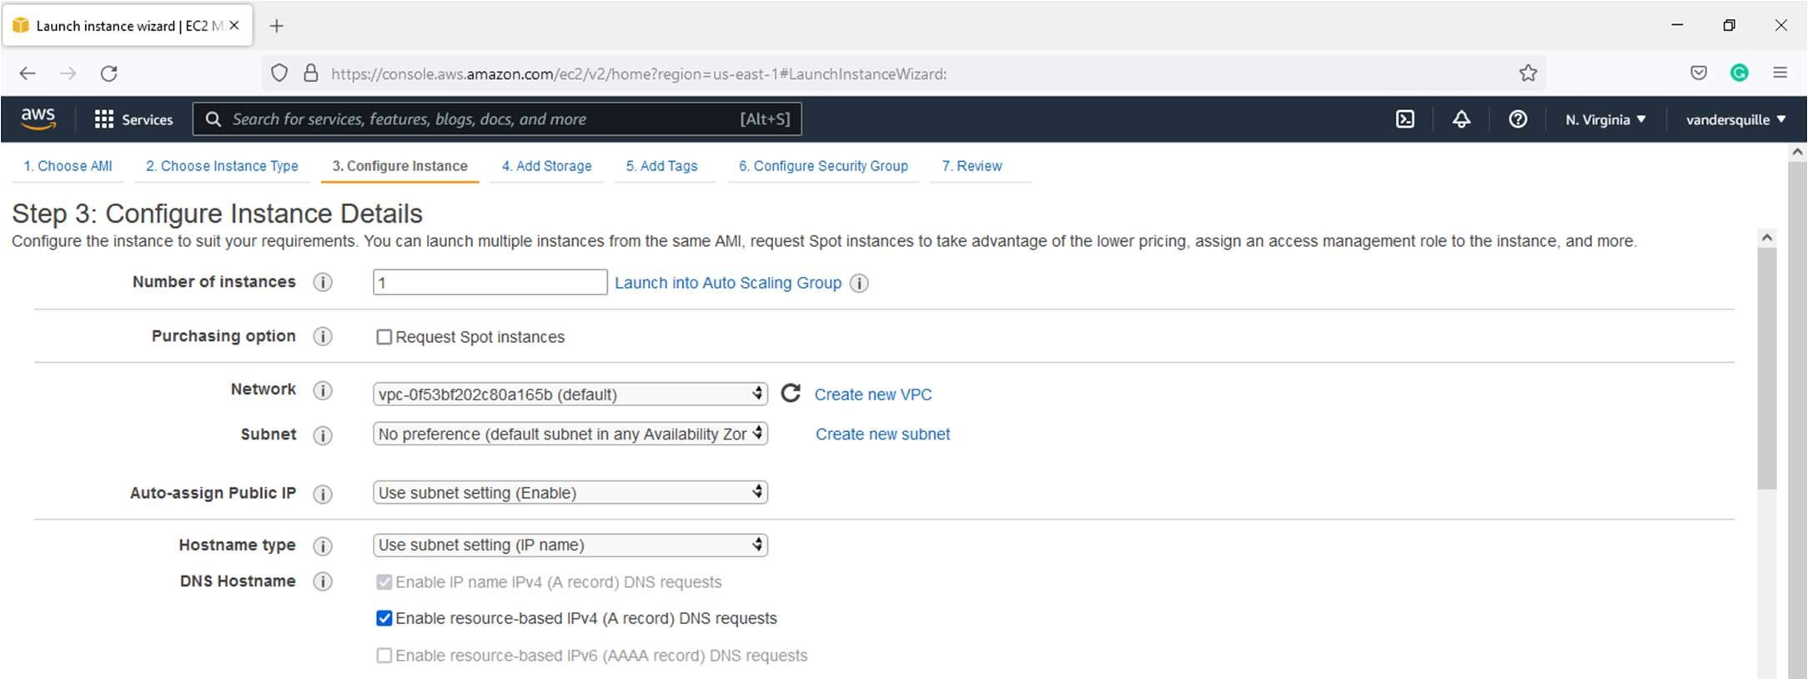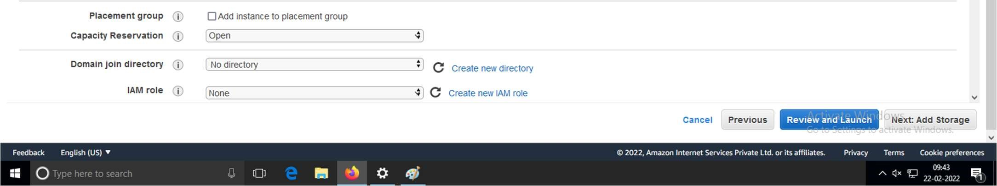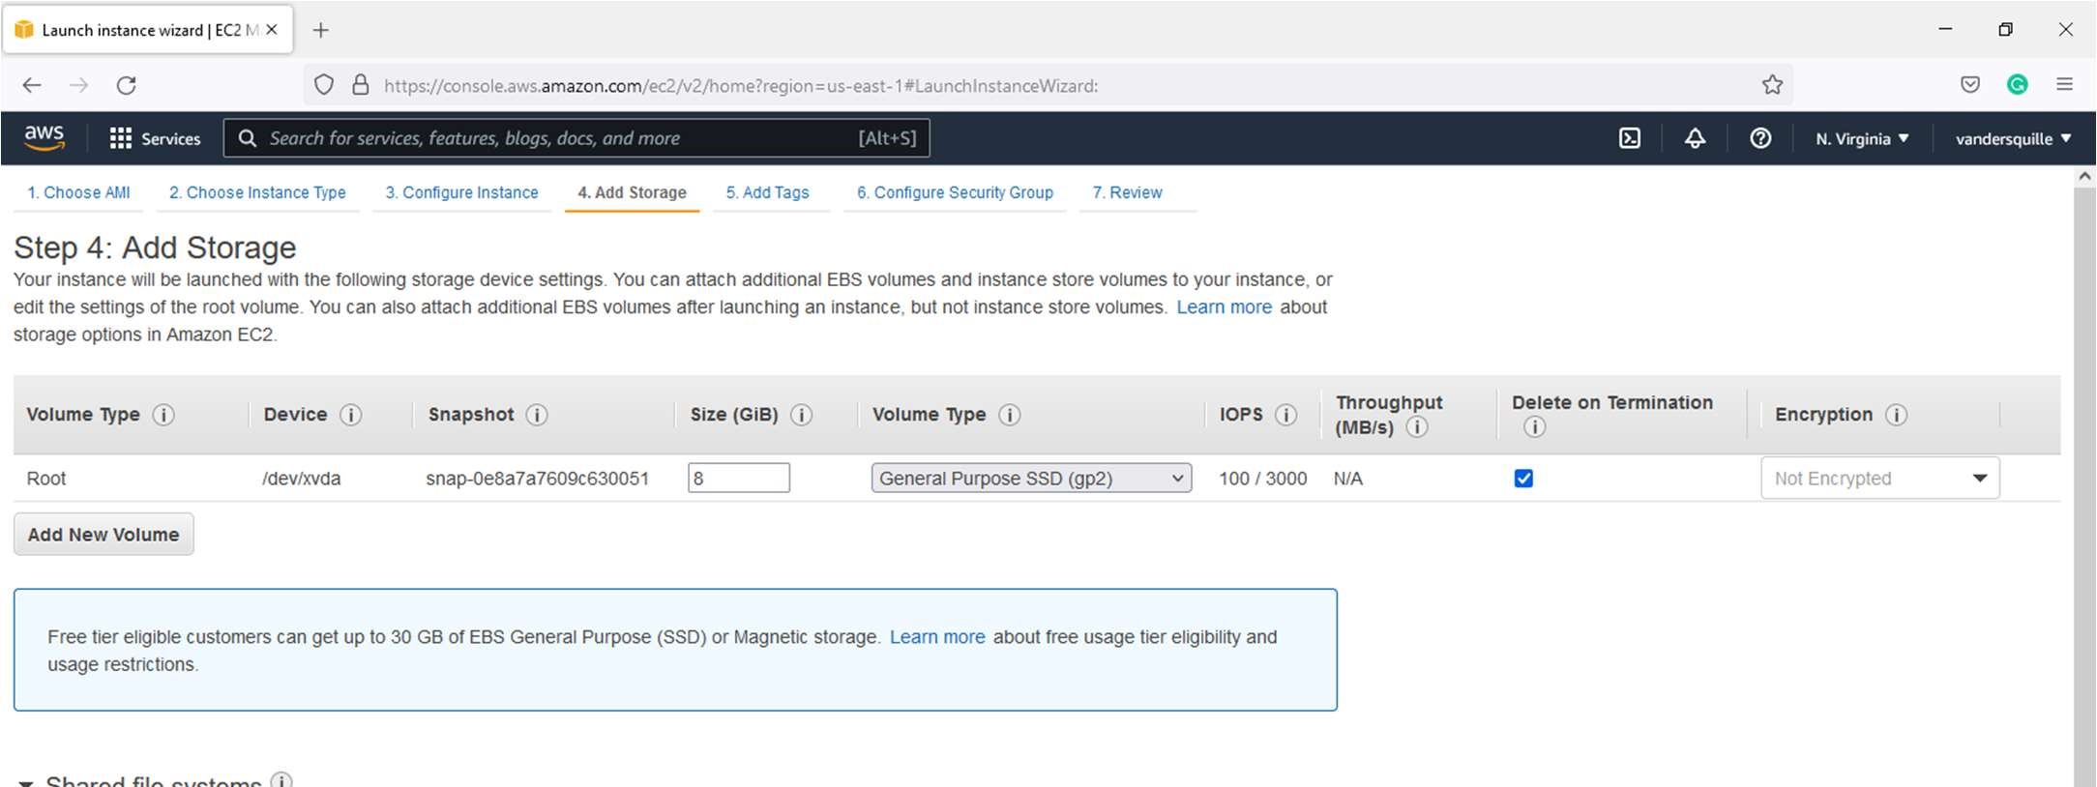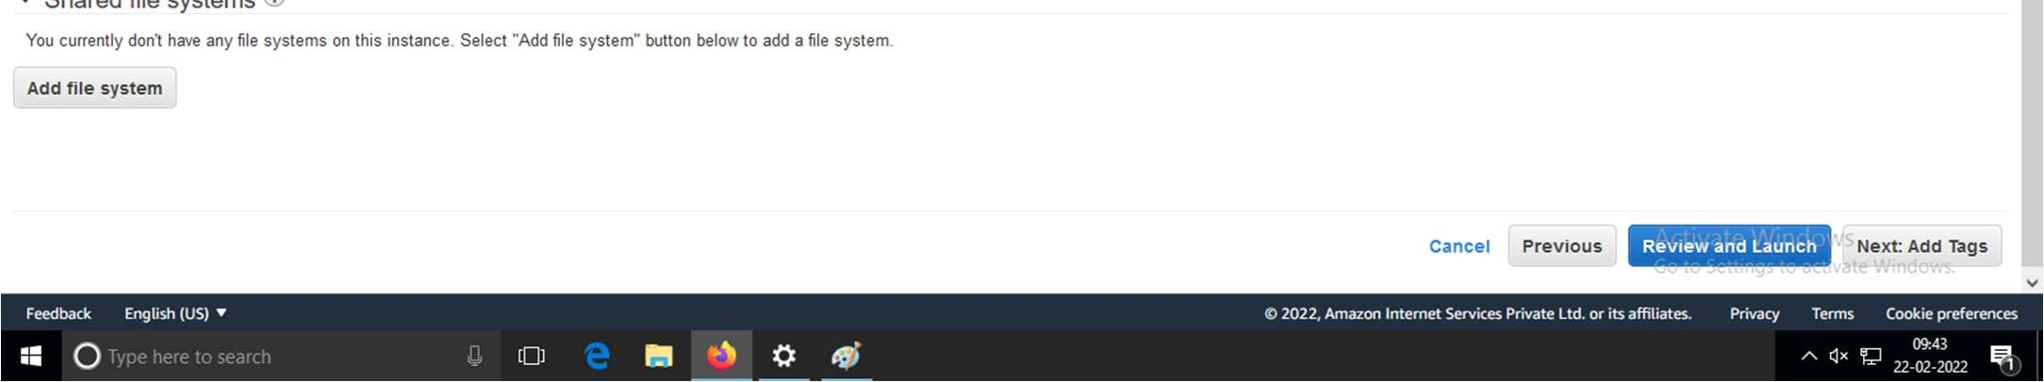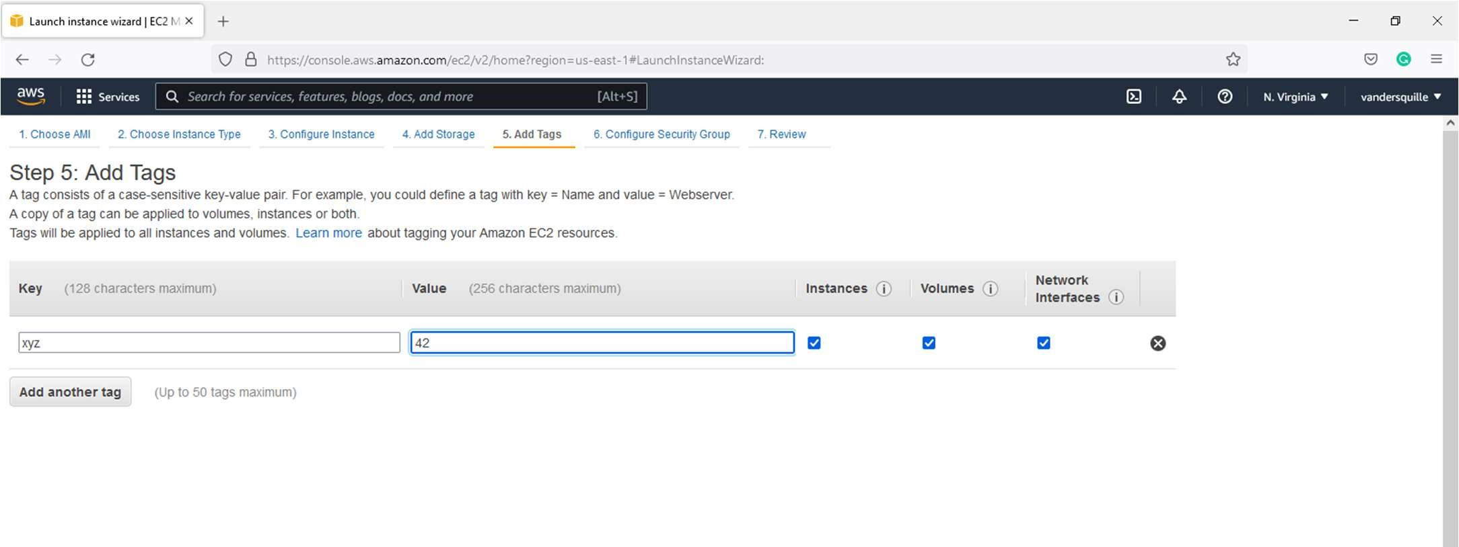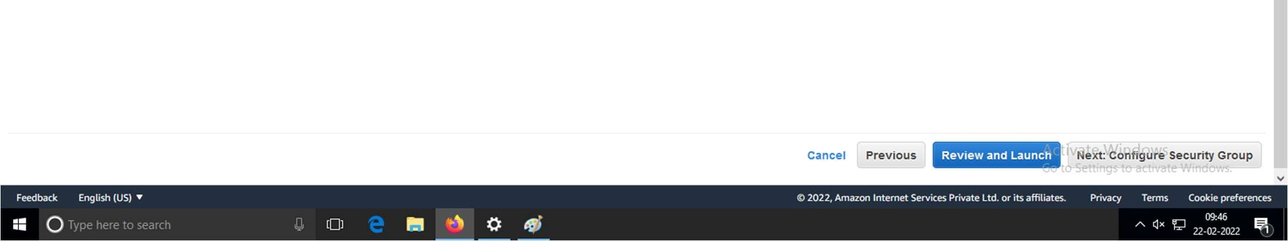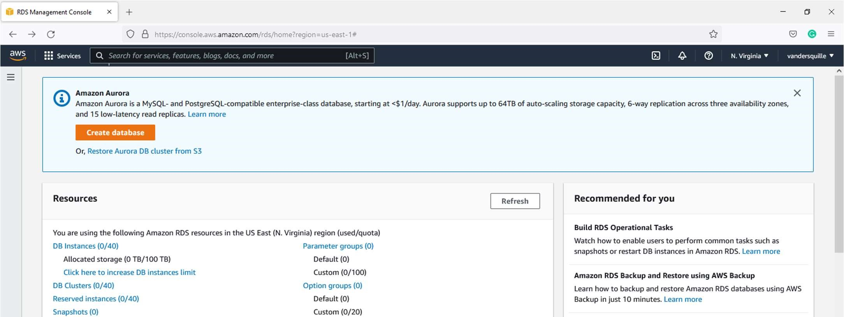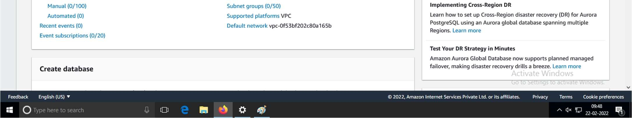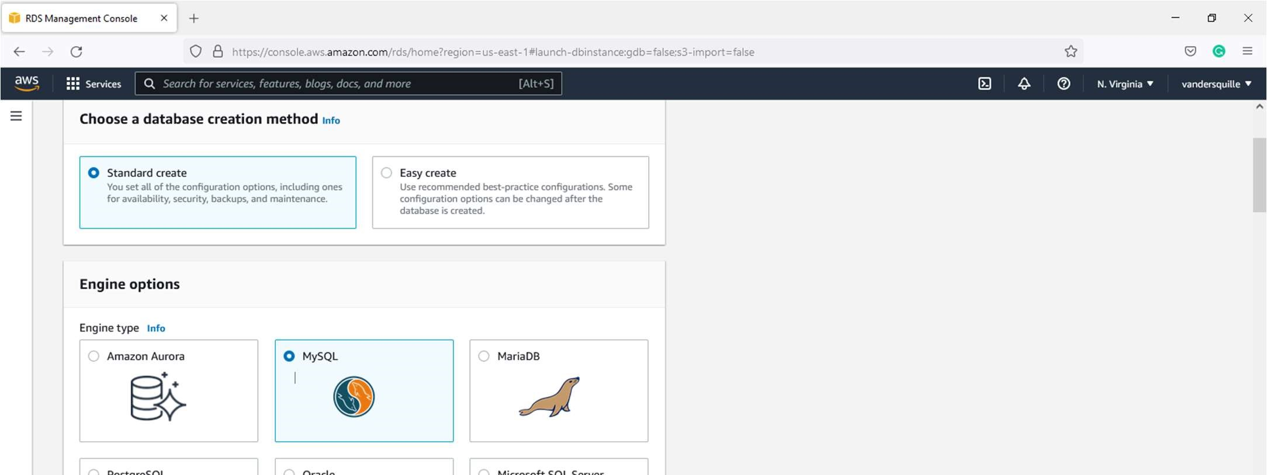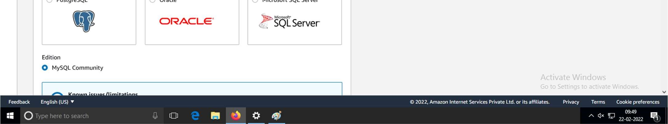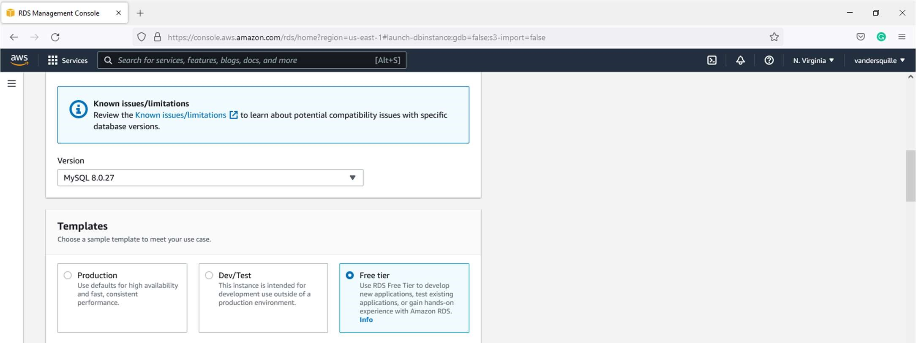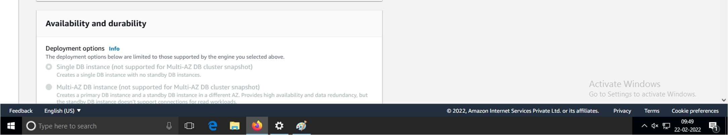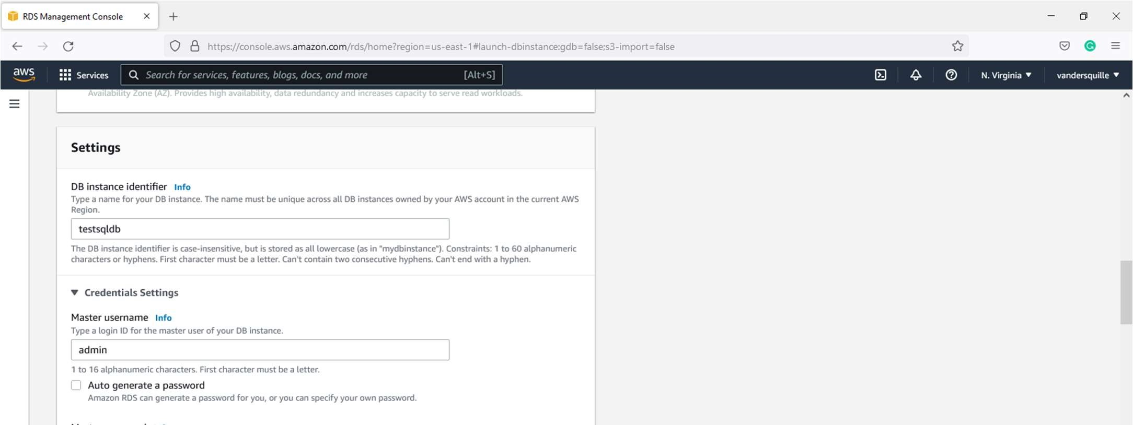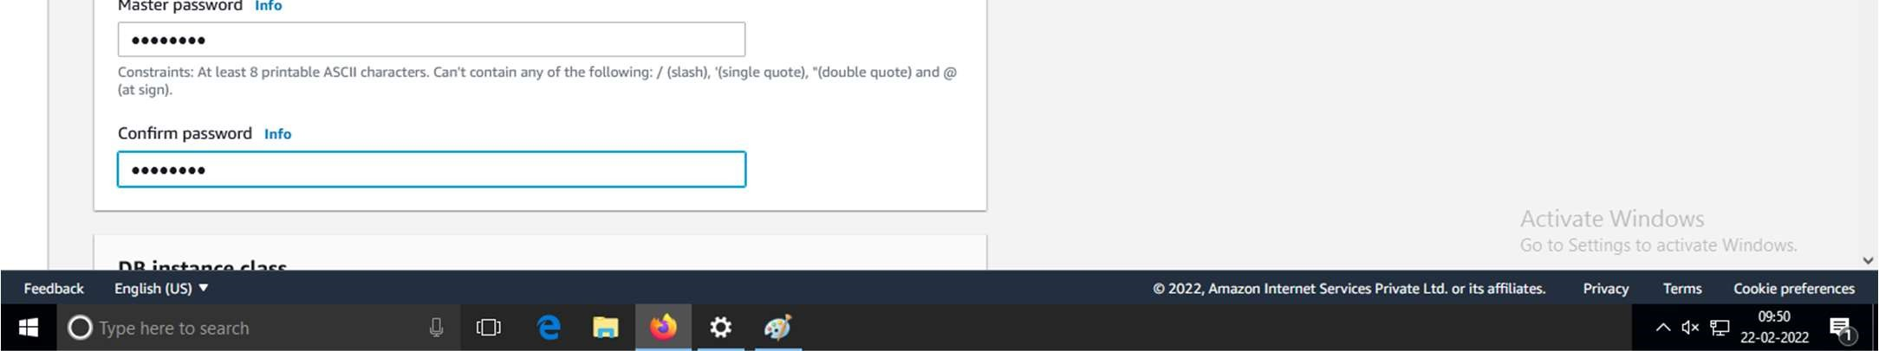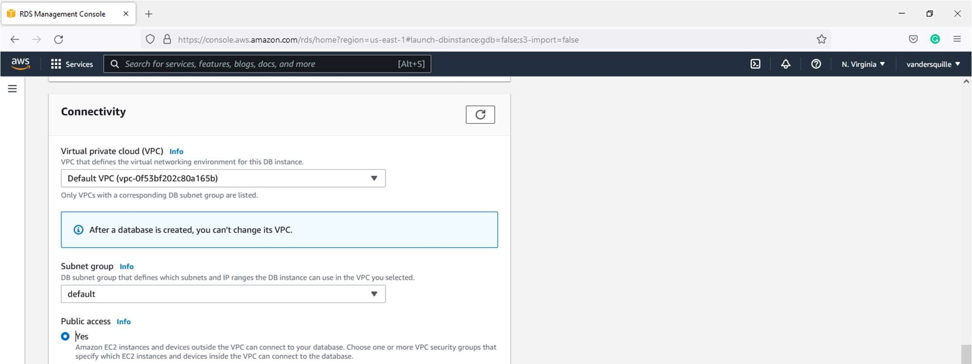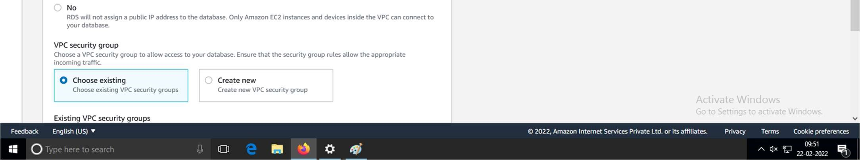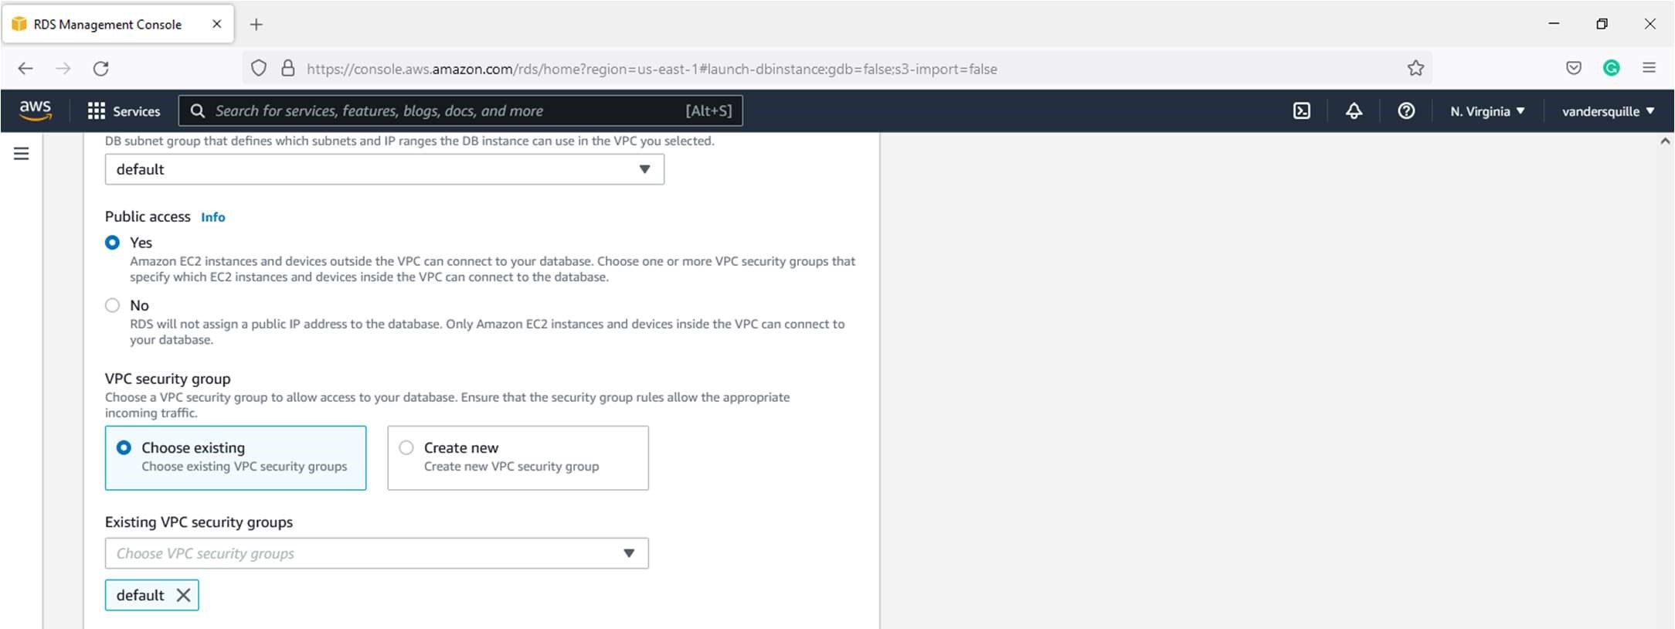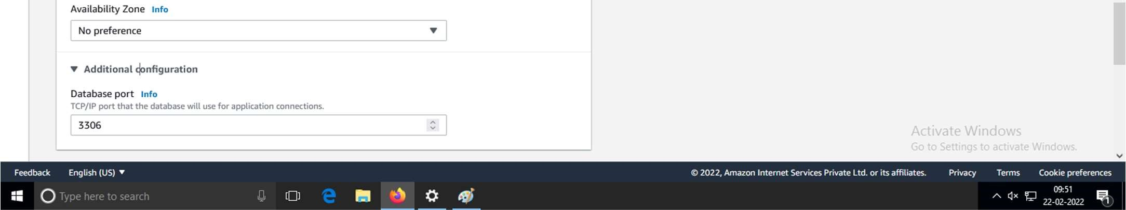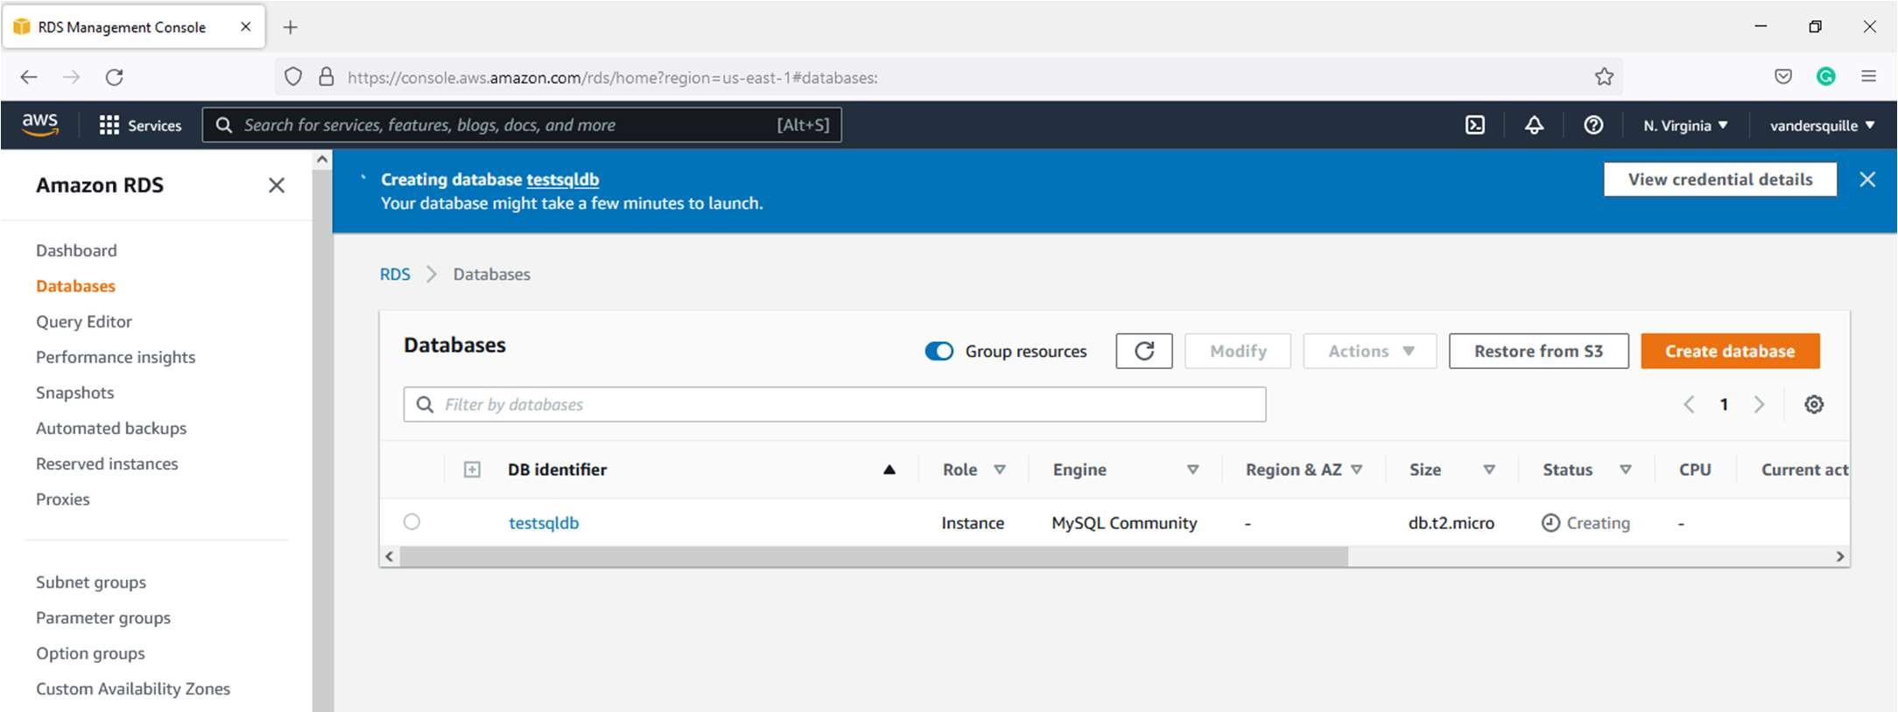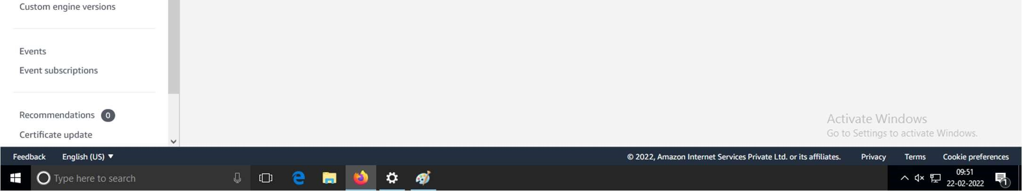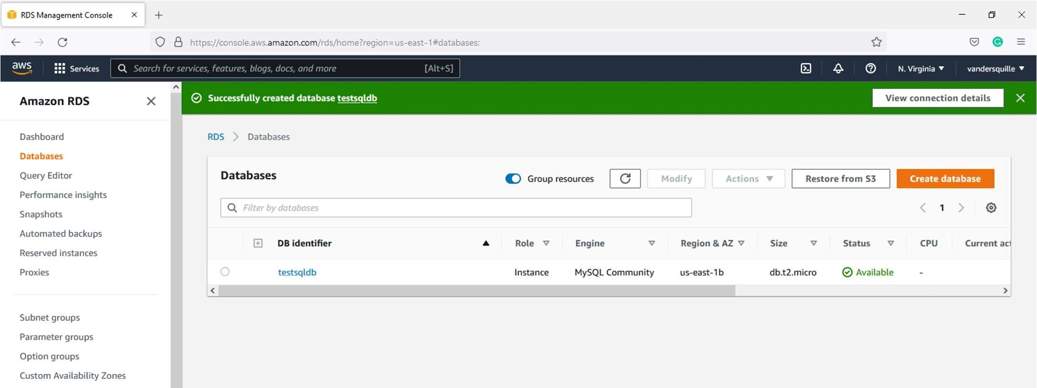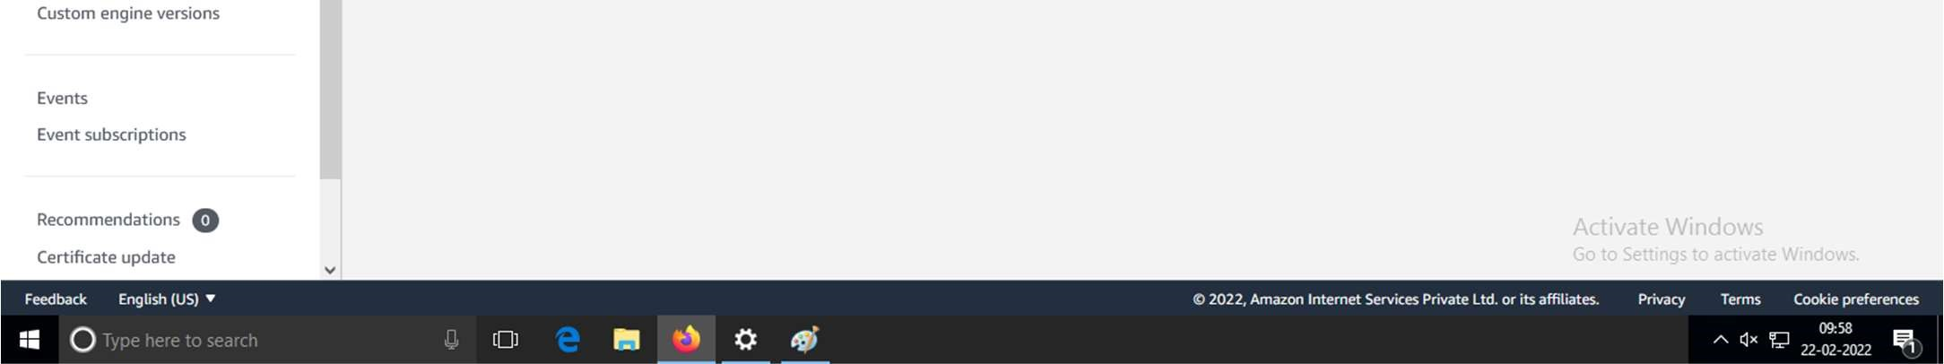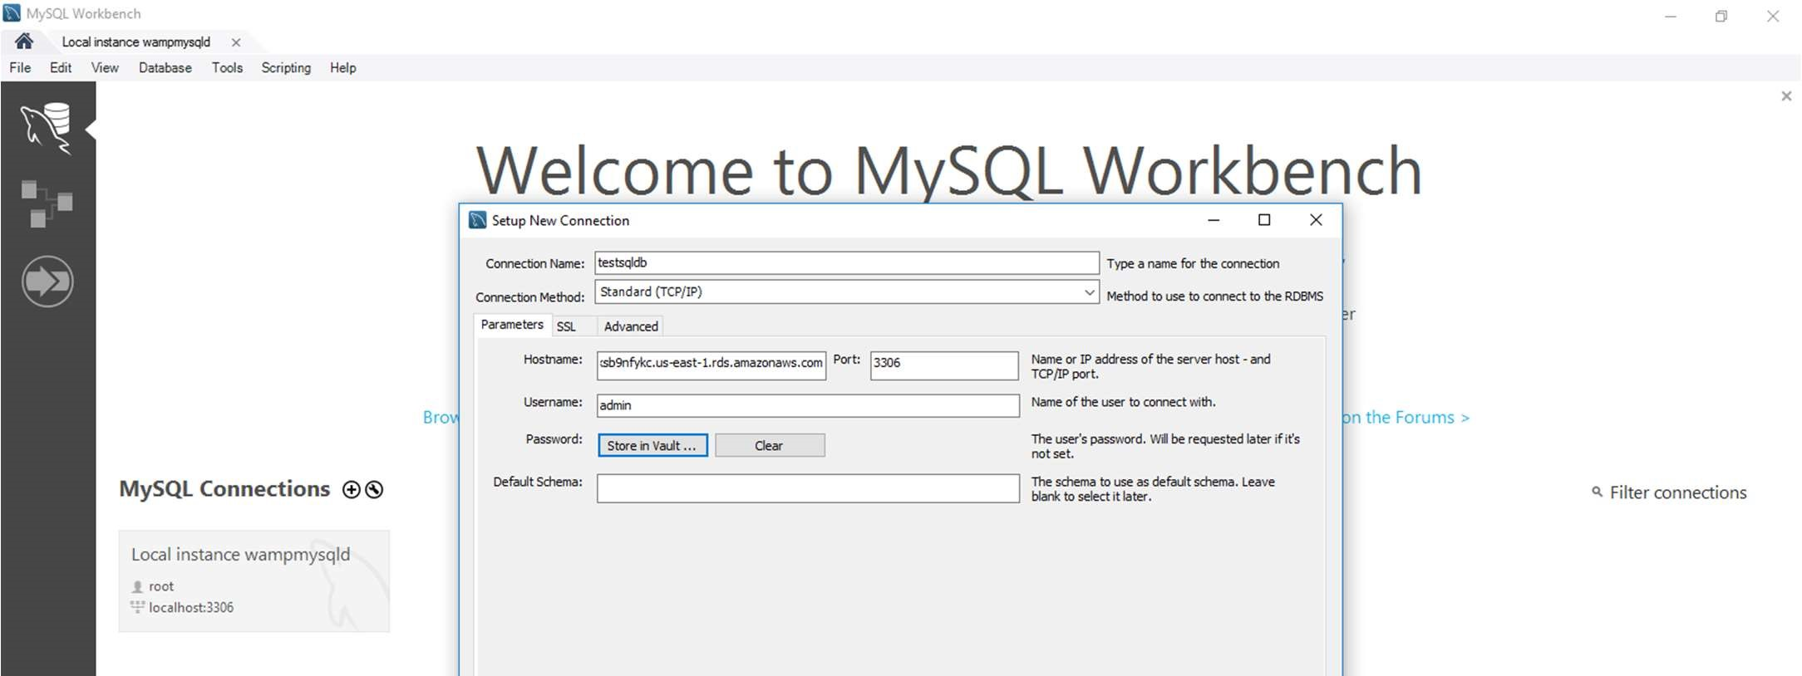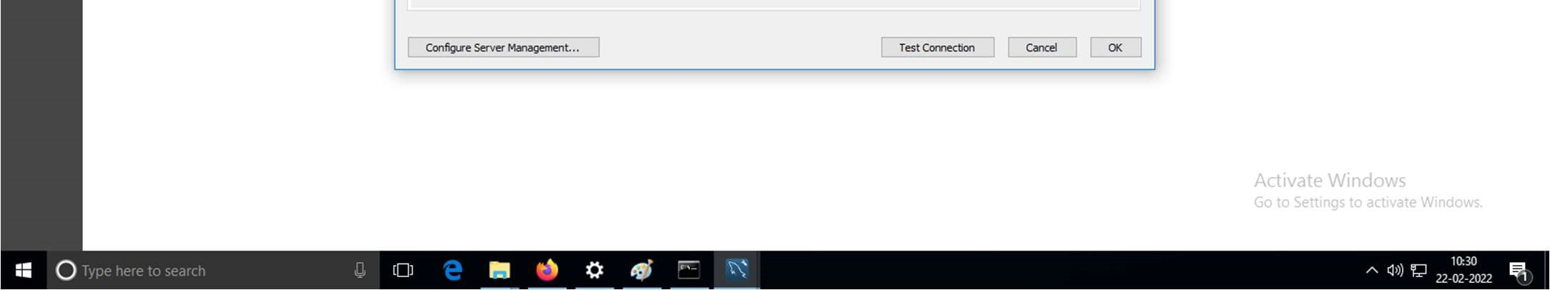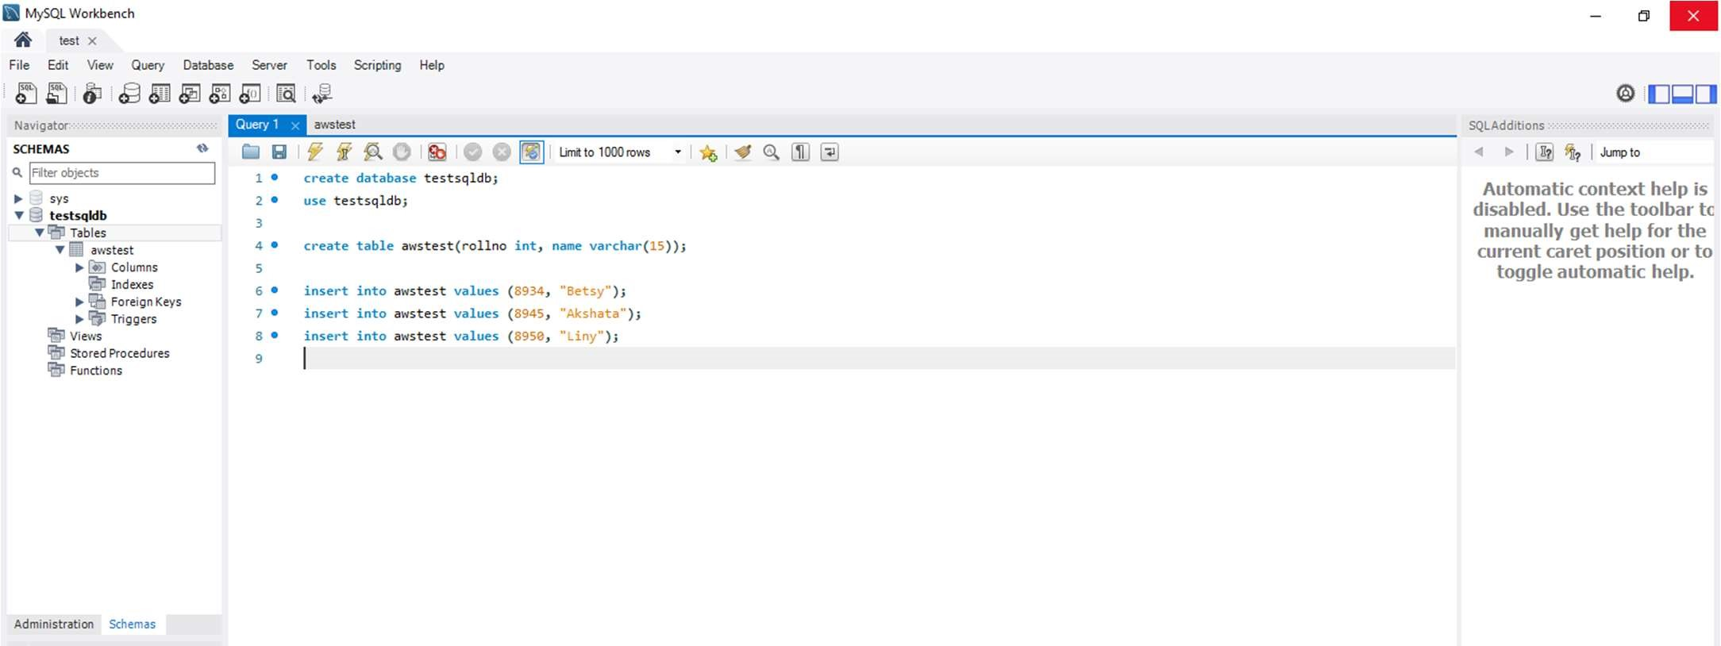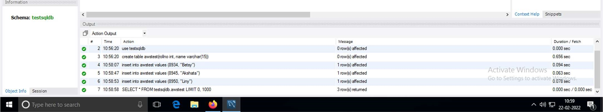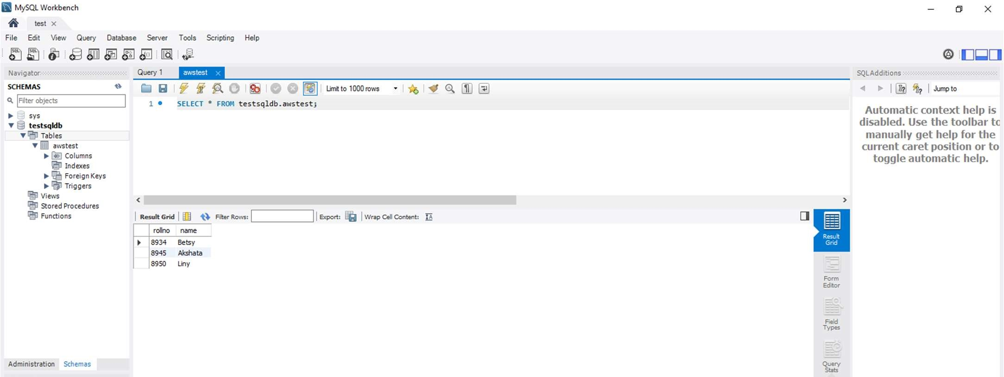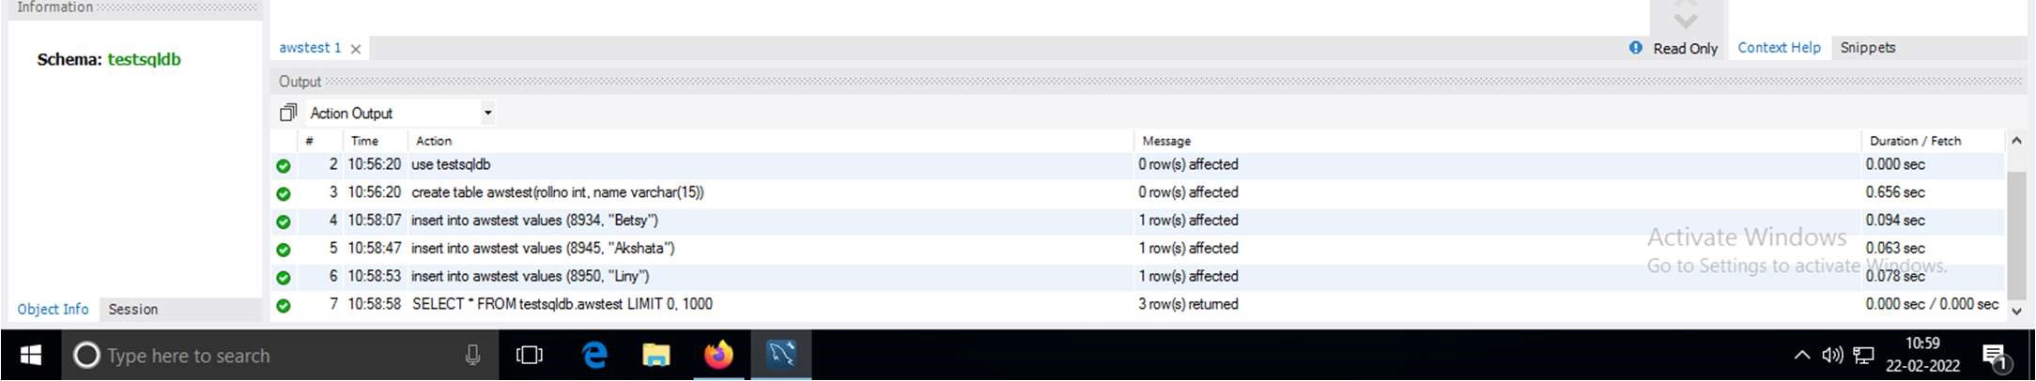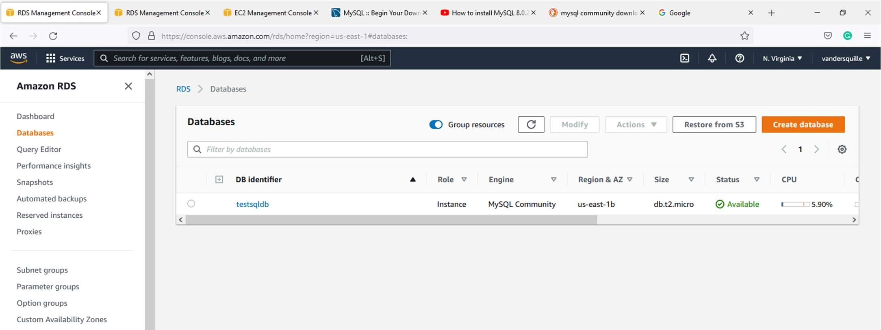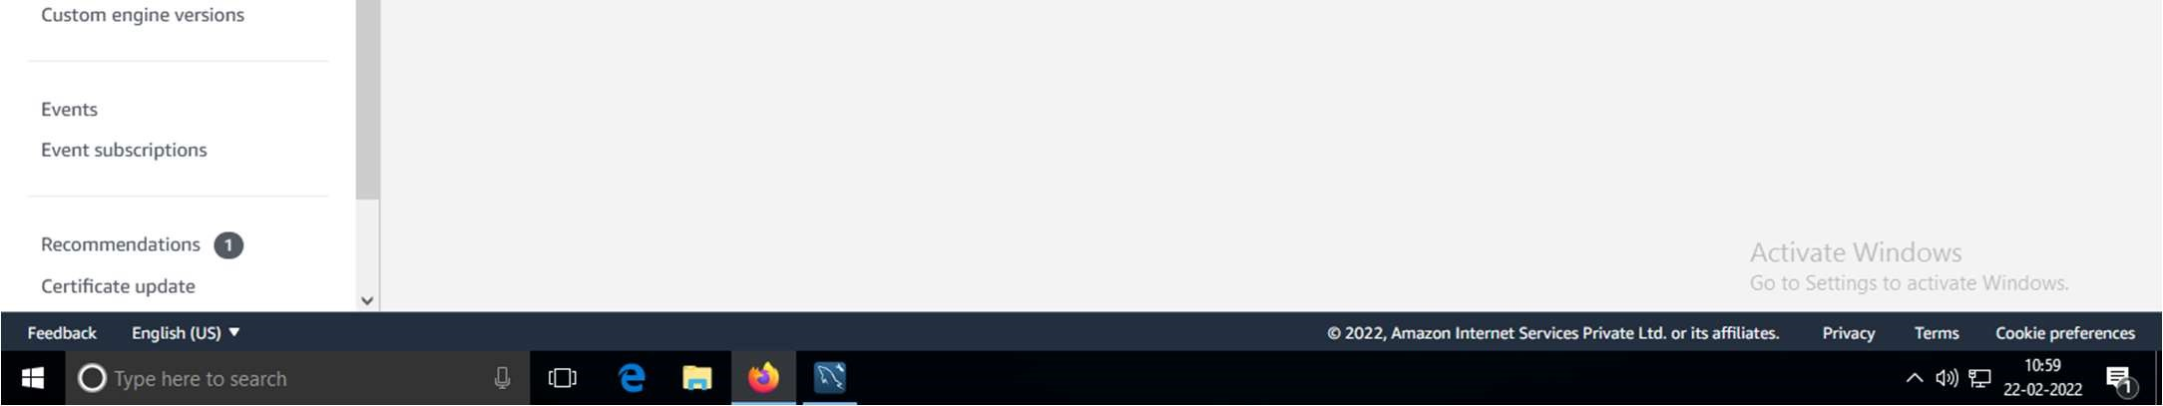

# A] CREATION OF EC2 INSTANCE

1. Create a security group
   1. Go to VPC
   2. Select Security Groups
   3. Select the security group which you prepared for the previous practical
   4. Edit inbound rules

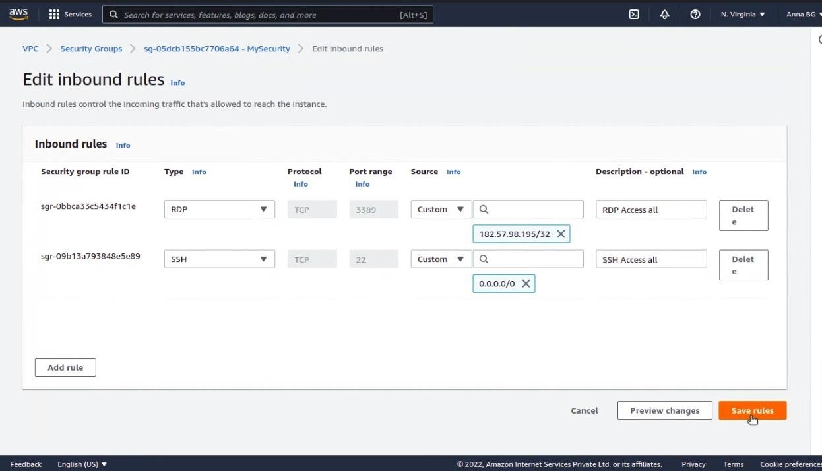

e) Add RDP and SSH

1. Search EC2. Go to instances. Choose launch instances.

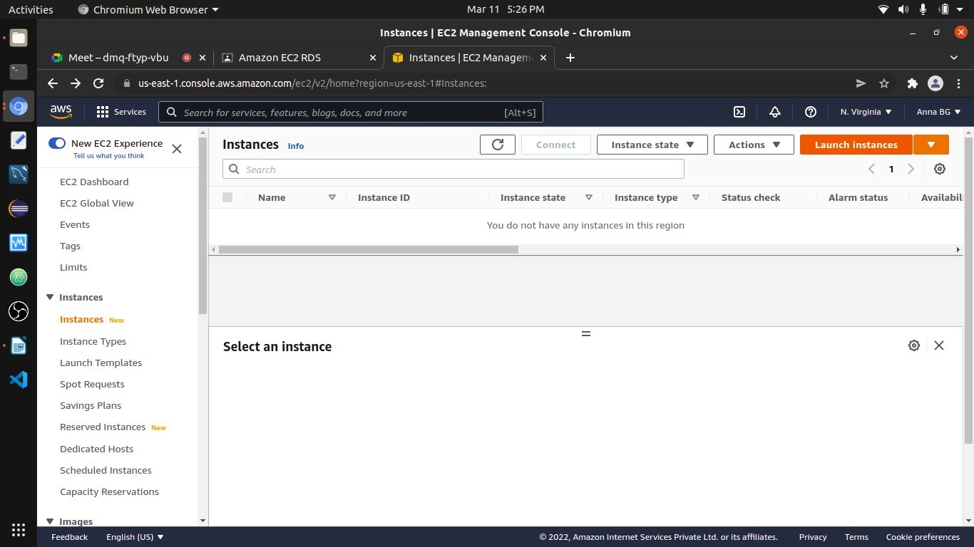

1. Choosing a Linux AMI

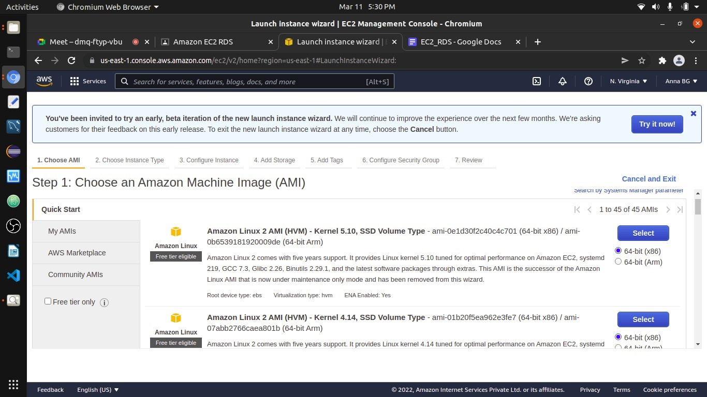

1. In Choose an Instance Type, directly go to the next step.

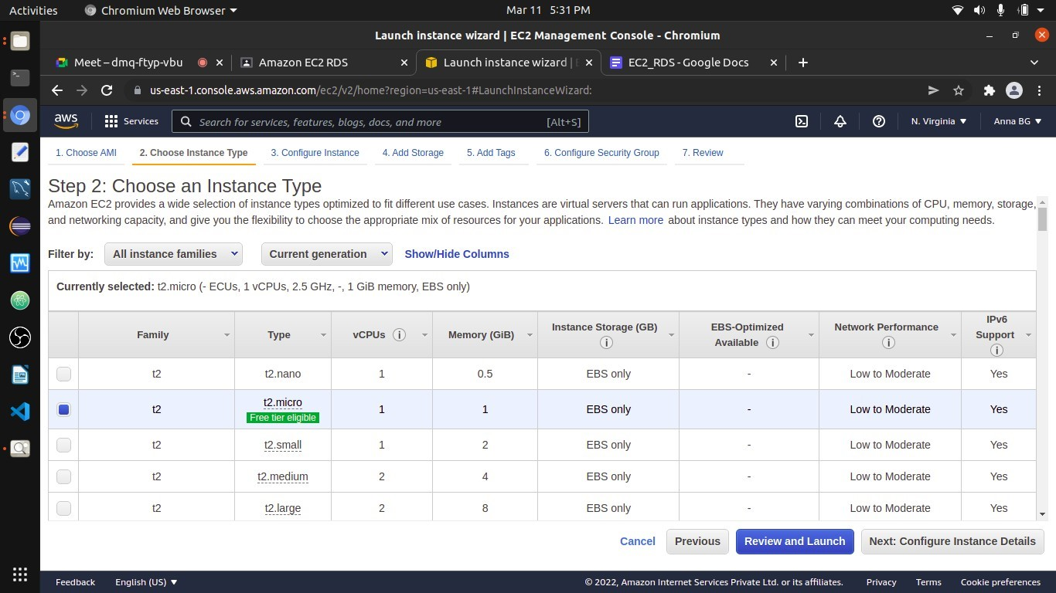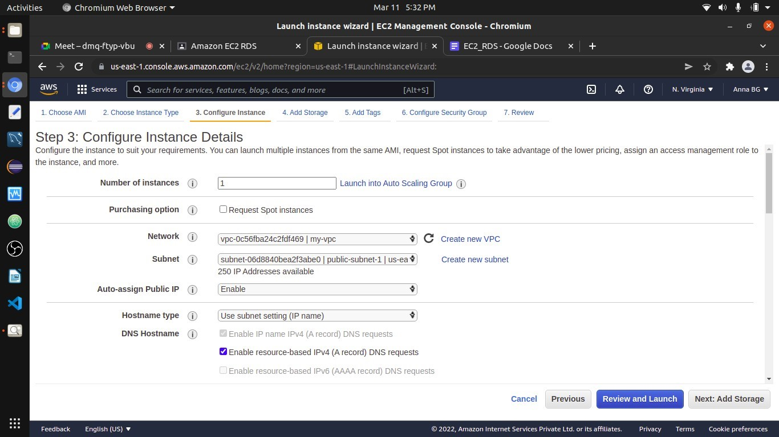

Select the VPC that you have created

Select a public subnet

Select enable

5)

Configuring Instance Details

6)

Add Storage

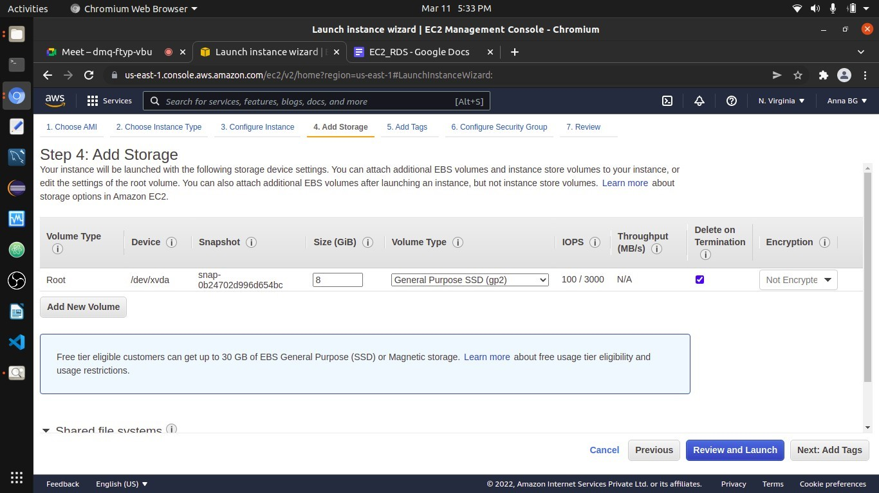

1. Add Tags (Key = Name & Value = EC2RDSlab-web)

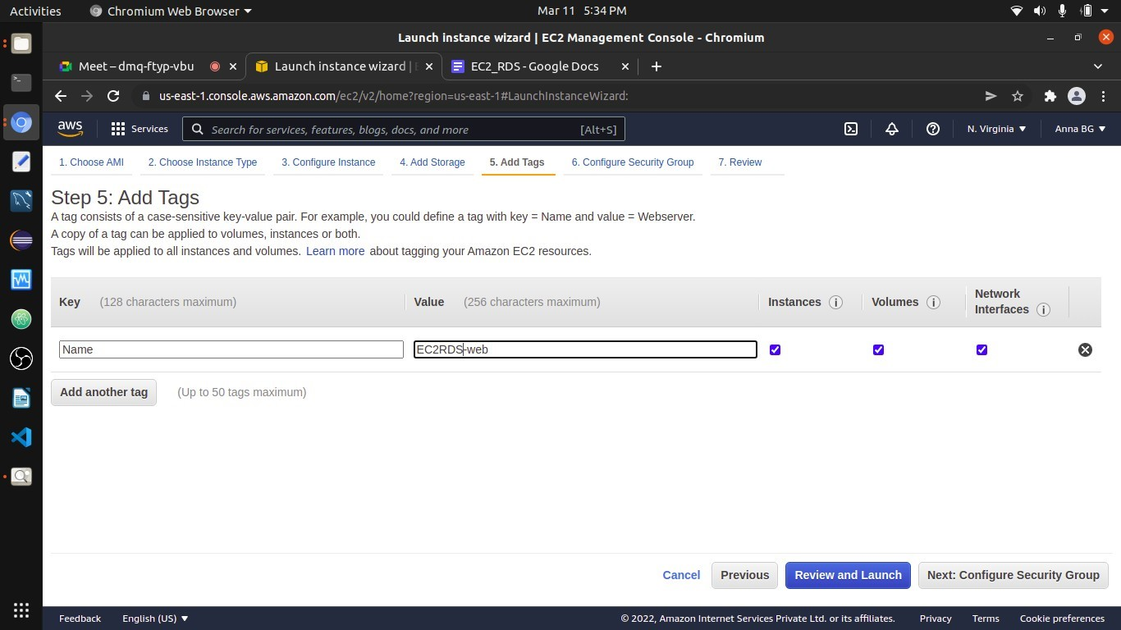

1. Configure Security Group

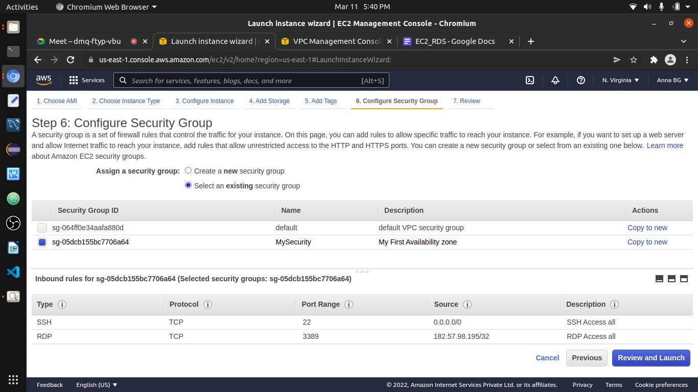

2.Select the security group that you had created

1

.Click on select an existing security group

1. Review and Launch

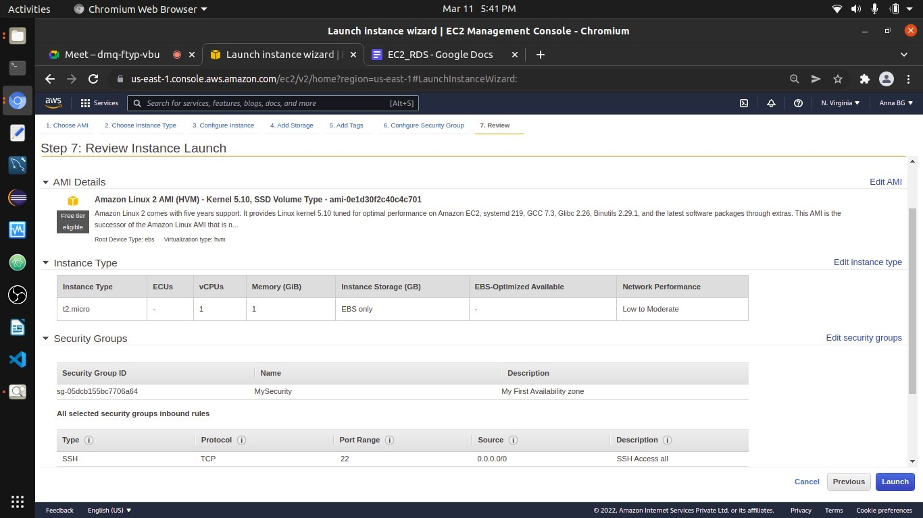

1. Launching the Instance (Select Choose an existing key pair, and select the key pair that you have created in the previous lab - EC2 VPC, else create a new key pair)

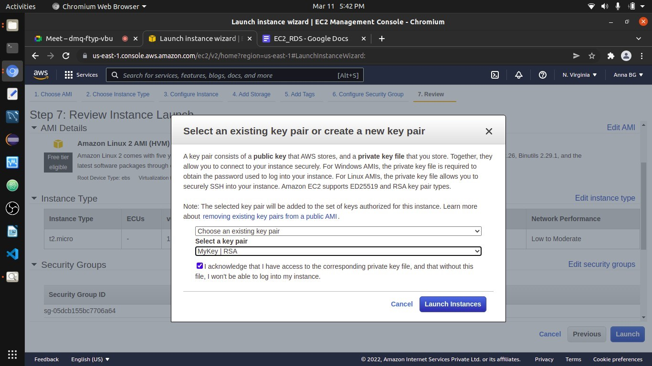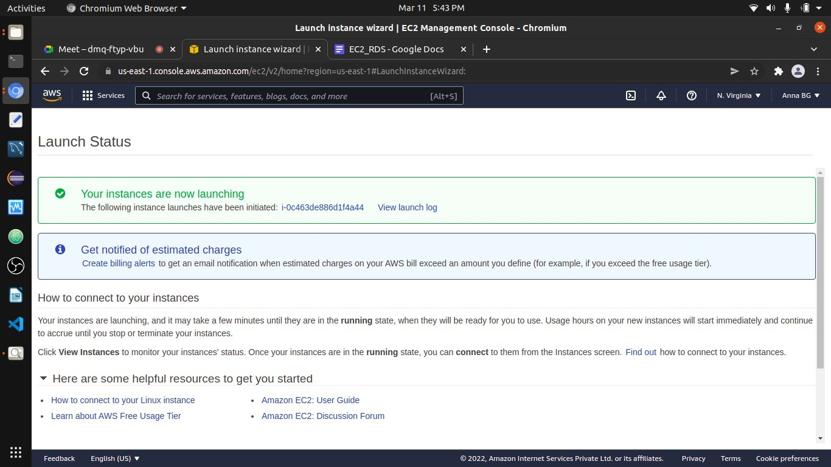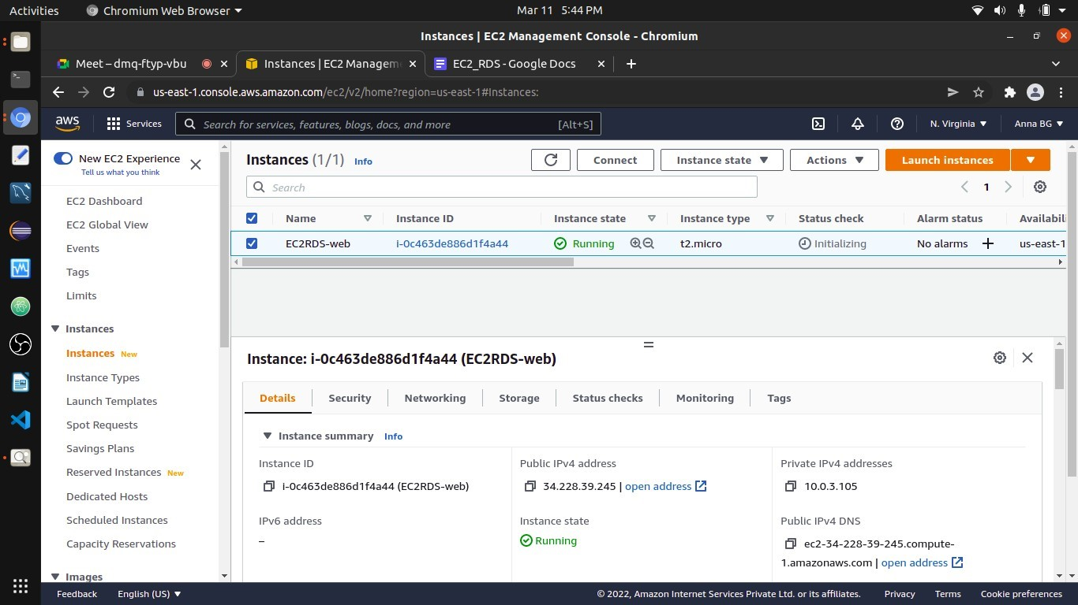

11)

EC2 Instance Created

B] Creation of RDS

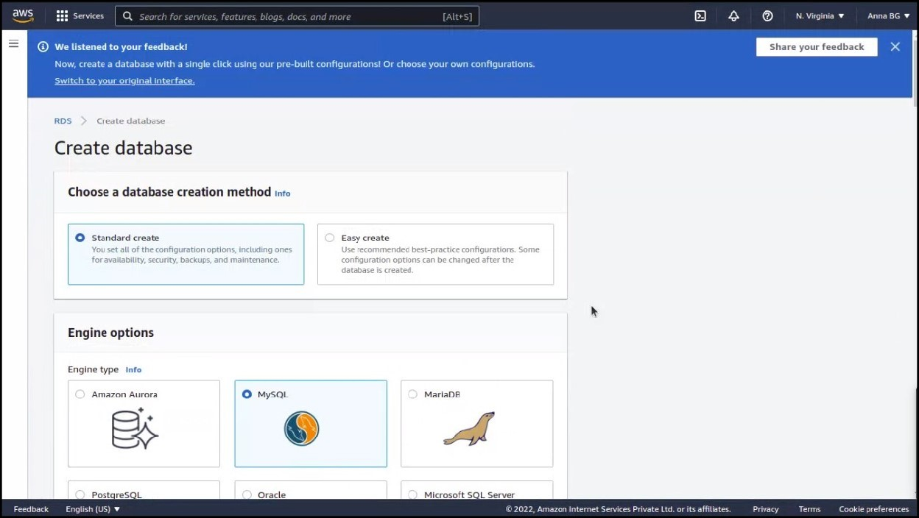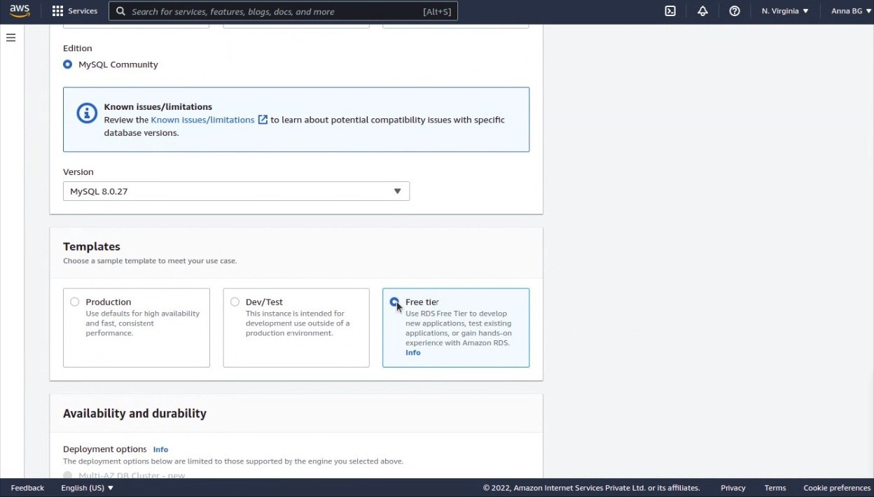

1)

Creating Database

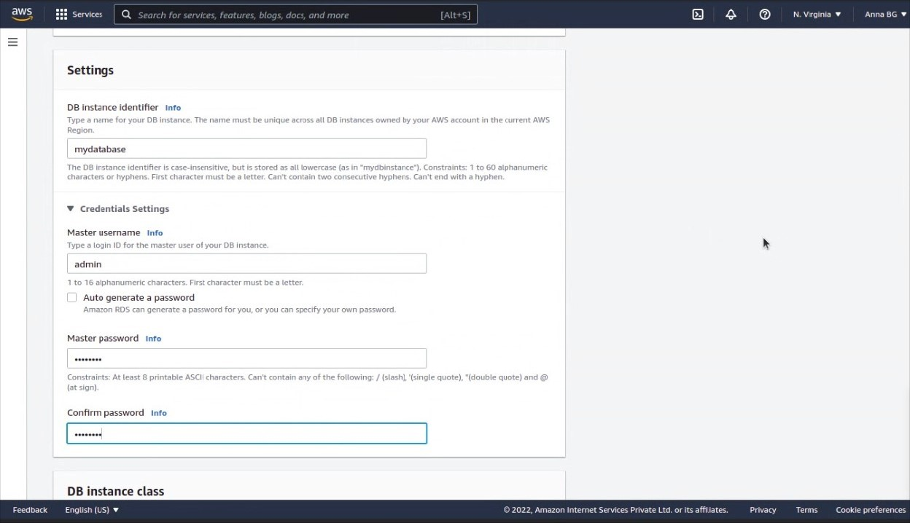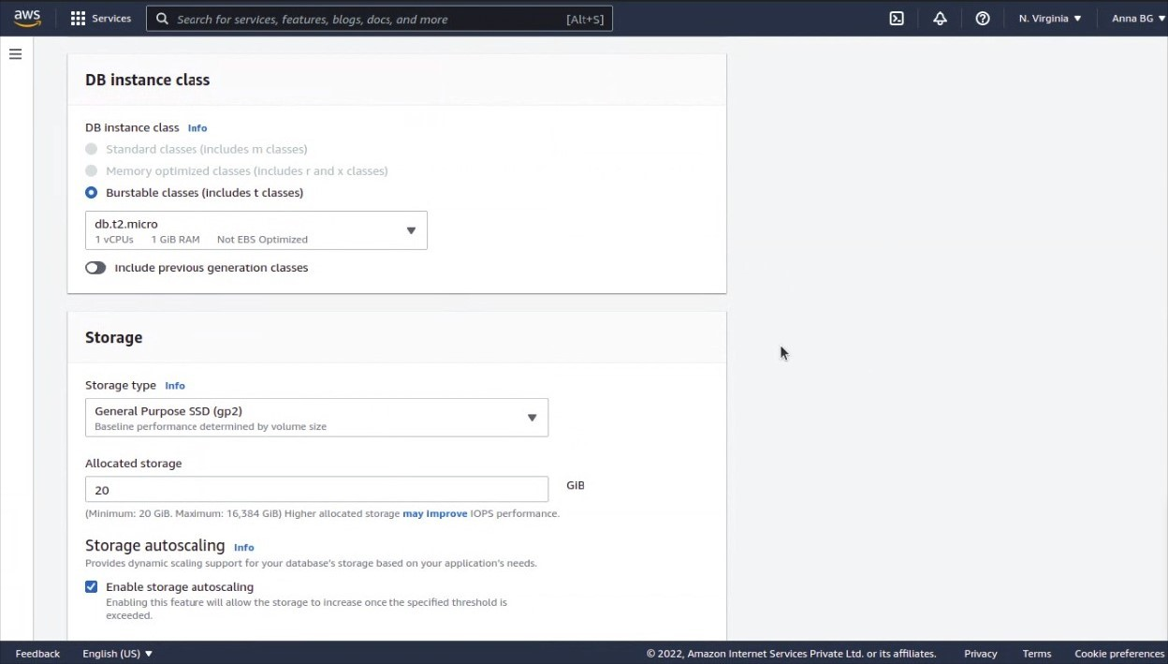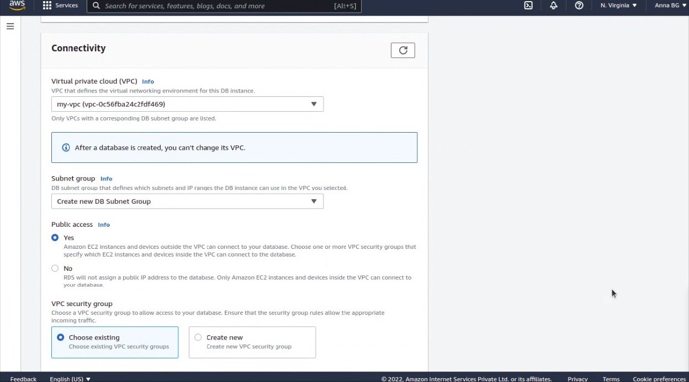

Choose the VPC that you have selected

while creating the EC2 instance

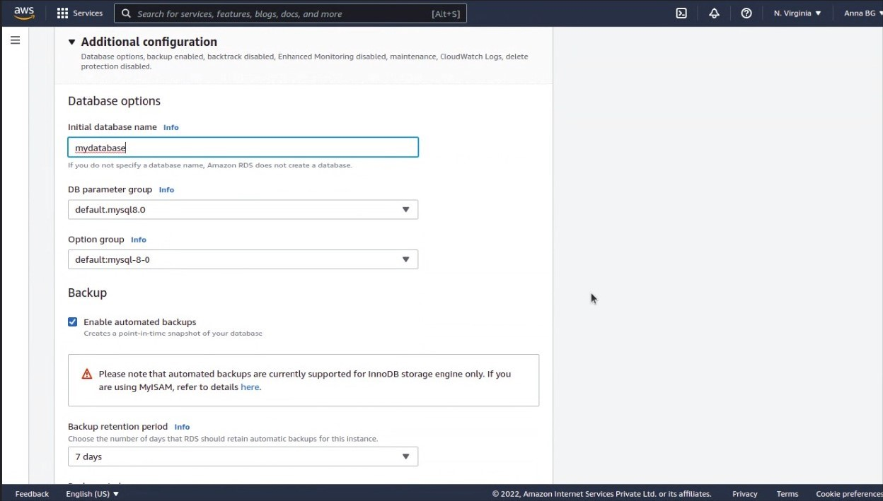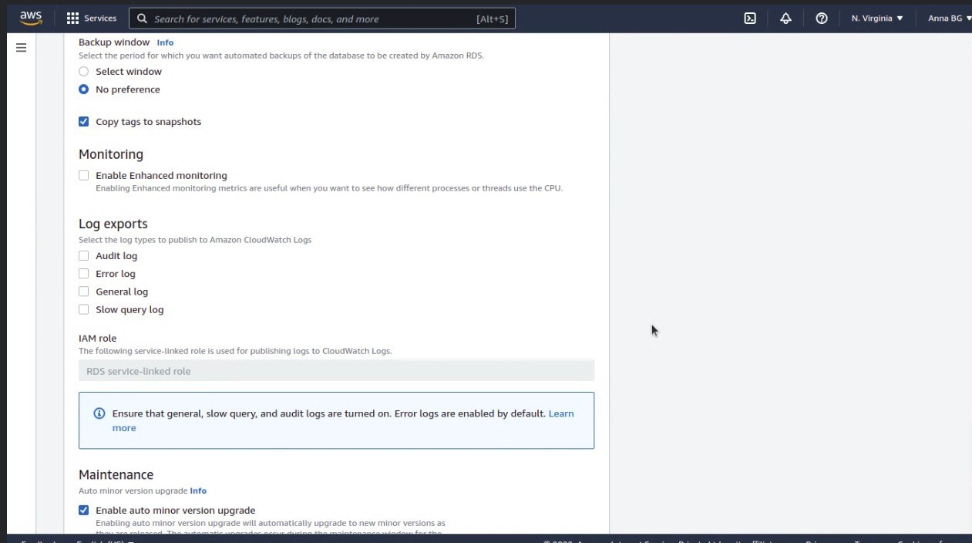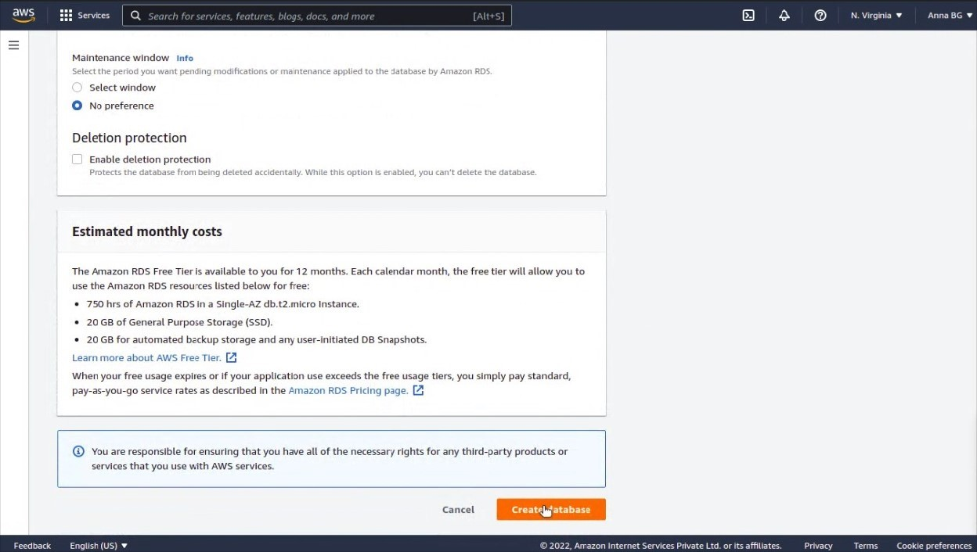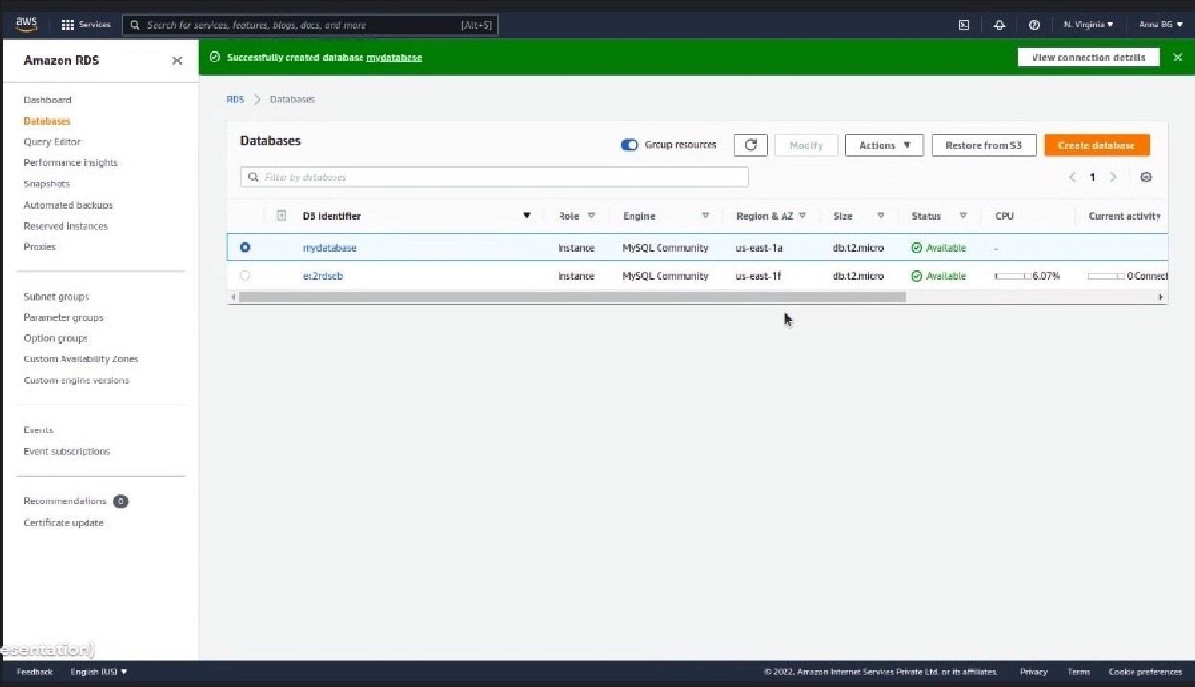

1. Click on mydatabase -> Connectivity & Security -> VPC Security groups -> Click on that link

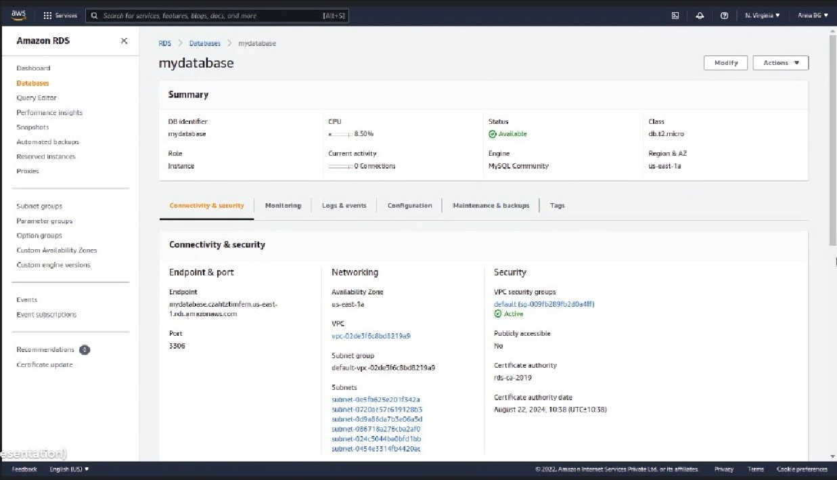

Click on this VPC Security group link

1. By going to the EC2 instance, copy the public IP address of the EC2 instance that you had created previously.

* 1. Click on Add rule
  2. Select type MySQL/Aurora
  3. Protocol -> TCP
  4. Port Range -> 3306
  5. Service -> Custom
  6. Insert the copied public IP address of the EC2 instance
  7. Save rules.

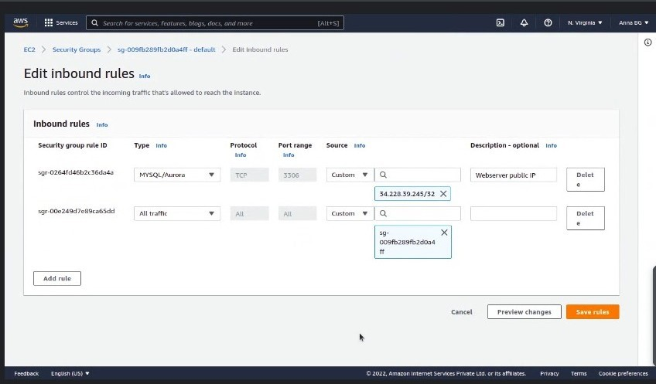

Insert the copied Public IP Address

of

EC2 instance

# C] Connection of EC2 instance to RDS

1. Go to the location where the .pem file is located (You might have got the .pem file from the last

EC2 VPC practical or else create a new Key pair and use that .pem file)

1. Go to your cmd/Terminal

1. In Terminal, type the following command:

ssh -i <<Key pair file name (.pem file)>> ec2-user@<<Public IP4 Address of EC2 Instance>>

1. Once the above command is executed, you will enter into the Amazon Machine Image (Linux

AMI) (the one which you had choosen while creating the EC2 instance (step A3))

1. Now enter the below command for accessing mysql:

mysql -h <<Endpoint of Created RDS Server>> -u <<master_username>> -p

1. Enter the password for mysql which you had given while creating the RDS.

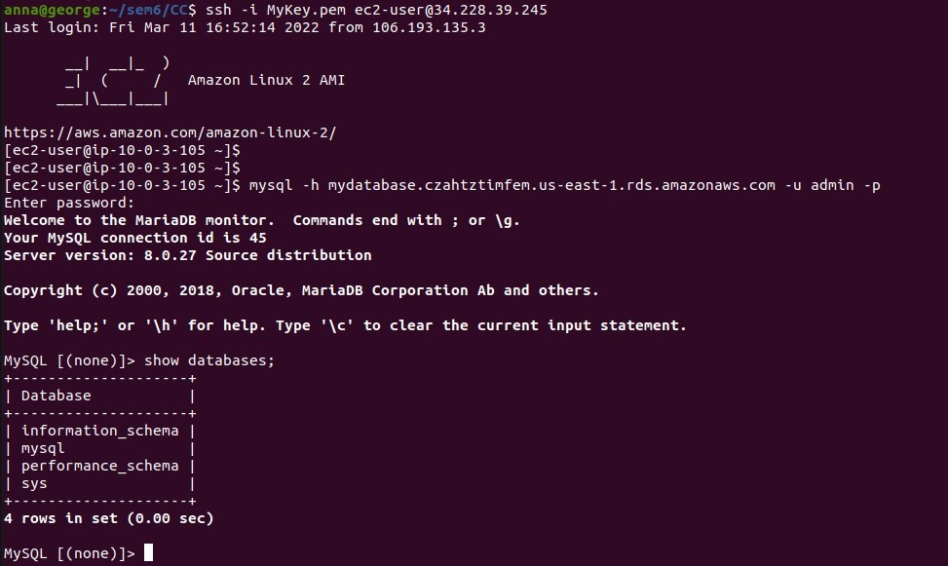

1. Now run these SQL commands

* + SHOW DATABASES;
  + CREATE DATABASE BOOKS;
  + SHOW DATABASES;
  + USE BOOKS;
  + CREATE TABLE BOOK (

BID INT NOT NULL,

TITLE VARCHAR(255) NOT NULL,

AUTHOR VARCHAR(255)

);

* + INSERT INTO BOOK(BID, TITLE, AUTHOR) VALUES (1, 'BECOMING', 'MICHELLE OBAMA');
  + SELECT * FROM BOOK;

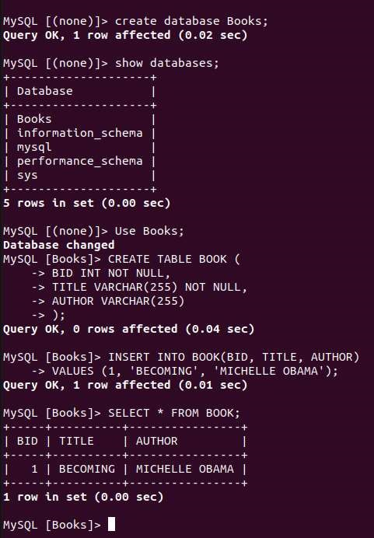

Experiment 6: Amazon Web Services RDS Post Lab Questions

Q1. What are the benefits of using Amazon AWS RDS system?

The most important benefits for using Amazon RDS.

## • Availability

AWS RDS is a highly available relational database that offers a feature called Multi-AZ, which provides a SLA up-time of 99.95%. With the Multi-AZ feature enabled in a production database, AWS provides a synchronous “standby” replica of every database in another “zone.” Since both the database and its replica are in sync, there is no chance of data loss.

AWS also offers a domain name server (DNS) to access RDS, so even if the master database instance goes down, an RDS automatic failover mechanism will change the master DNS to a replica in order to achieve high availability.

## • Scalability

Database scalability can prove to be a real challenge if you try to scale your own, self-hosted database. Handling mandatory downtimes due to upgrades or infrastructure requirements can be quite tricky and is just the beginning of your scalability responsibilities. That is why one of AWS RDS key advantages is its scaling service. Moreover, MySQL RDS offers two levels of scalability features: vertical and horizontal.

Vertical Scalability /Scaling Up – With RDS, Amazon enables push-button vertical scaling. This means that you can scale the size of an RDS instance [memory, CPU, PIOPS etc] or disk, either up or down, with the click of a button. AWS may need to stop the instance for vertical scaling, but if you have enabled the Multi-AZ feature, AWS will apply any scaling to your replicas first to ensure that they are available for use when the master is being scaled. AWS also offers the option to either configure immediate scaling or scale during weekly maintenance during non-peak hours.

## • Horizontal Scalability /Scaling Out –

Horizontal scalability is an approach that distributes the total database across many RDS instances that will work together. RDS MySQL offers read replica functionality using MySQL’s built-in replication feature, offering read-only database instances to serve read traffic. In order to achieve true database elasticity, a database needs to scale out beyond a simple master-slave setup. Amazon recommends that data be distributed across multiple RDS instances. This way, each RDS contains a portion of the complete database. By utilizing ScaleBase’s AWS AMI, you can create a real distributed relational database with many RDS instances working together as one, and without making modifications to your application. This brings you massive horizontal scaling, and after scaling out to a distributed RDS database, all AWS value-added services continue to work.

## • Performance

AWS RDS offers PIOPS (Provisioned IOPS) in order to achieve fast, consistent and predictable Input/Output (I/O) performance. This is ideal for online transaction processing (OLTP) databases or high I/O centric applications. With MySQL RDS, you can set up as many as 30,000 IOPS. The more IOPS you have set up, the more concurrent request processes increase, which in turn increases throughput and decreases latency to achieve higher database performance.

## • Backup

AWS RDS provides two types of backup mechanisms which are both very easy to setup:

Automated backup – This functionality automatically performs a full daily snapshot of a database’s data (during a preferred window of time set up by the user). It also captures your transaction logs as well as any updates to your RDS database.

Point-in-Time snapshots – RDS database snapshots are user initiated. Unlike automated backup, which is performed once a day, point-in-time snapshots can be performed as many times as desired.

Q2. Explain any use case for AWS RDS system

Amazon Relational Database Service (RDS) allows users to set up, operate, and scale a database in the cloud. The vendor states it provides cost-efficient and resizable capacity while automating timeconsuming administration tasks such as hardware provisioning, setup, patching, and backups. This frees users to focus on applications so they can give them the fast performance, high availability, security, and compatibility they need.

Amazon RDS is available on several database instance types - optimized for memory, performance or I/O - and provides you with six familiar database engines to choose from including Amazon Aurora, MySQL, PostgreSQL, MariaDB, Oracle Database, and SQL Server.

Q3. What are instances in Amazon EC2?

Amazon EC2 provides a wide selection of instance types optimized to fit different use cases. Instance types comprise varying combinations of CPU, memory, storage, and networking capacity and give you the flexibility to choose the appropriate mix of resources for your applications. Each instance type includes one or more instance sizes, allowing you to scale your resources to the requirements of your target workload.

Types of EC2 Instances -

Current Generation

* Amazon EC2 M6g instances are powered by Arm-based Amazon Web Services Graviton2 processors. They deliver up to 40% better price/performance over current generation M5 instances and offer a balance of compute, memory, and networking resources for a broad set of workloads.
* Amazon EC2 T4g instances are powered by Arm-based Amazon Graviton2 processors and deliver up to 40% better price performance over T3 instances for a broad set of burstable general purpose workloads.
* Amazon EC2 M5 Instances are powered by Intel Xeon® Platinum 8175 3.1GHz processors. With M5d instances, local NVMe-based SSDs are physically connected to the host server and provide block-level storage that is coupled to the lifetime of the M5 instance.

Q4. What are AMIs in Amazon EC2?

An Amazon Machine Image (AMI) provides the information required to launch an instance. You must specify an AMI when you launch an instance. You can launch multiple instances from a single AMI when you need multiple instances with the same configuration. You can use different AMIs to launch instances when you need instances with different configurations.

An AMI includes the following:

* One or more Amazon Elastic Block Store (Amazon EBS) snapshots, or, for instance-store-backed AMIs, a template for the root volume of the instance (for example, an operating system, an application server, and applications).
* Launch permissions that control which AWS accounts can use the AMI to launch instances.
* A block device mapping that specifies the volumes to attach to the instance when it's launched.

Q5. What are the features of Amazon Database?

## • Easy to Administer

AWS RDS makes it simple to travel from project conception to deployment. Use the AWS Management Console, the AWS RDs Command-Line Interface, or easy API calls to access the capabilities of a production-ready relational database in minutes.

No need for infrastructure provisioning and no need for putting in and maintaining information software package.

## • Available and Durable

AWS RDs runs on a similar extremely reliable infrastructure employed by alternative Amazon Web Services. After the surveillance of a Multi-AZ decibel Instance, Amazon RDs replicates the data to a standby instance in a different Availability Zone (AZ).

Amazon RDs has several alternative options that enhance dependability for vital production databases, as well as automated backups, info snapshots, and automatic host replacement.

## • Security Features

Amazon RDS makes it simple to manage network access to your database.

AWS RDs conjointly helps you to run your database instances in Amazon Virtual Private Cloud that allows you to isolate your database instances associated to attach to your existing IT infrastructure through an industry-standard encrypted IPsec VPN.

Several Amazon RDs engine sorts supply secret writing at rest and secret writing in transit.

## • Fast Processing

Amazon RDS supports the foremost exacting database applications. The user has to choose from 2 SSD-backed storage options. The first one is optimized for high-performance OLTP applications and the second for different cost-efficient general use.

Additionally, Amazon Aurora provides performance on par with industrial databases at 1/10th the price.

Q6. Which of the AWS DB services is a NoSQL database and server-less, and delivers consistent single-digit millisecond latency at any scale?

1. Amazon Aurora
2. MariaDB

## 3. DynamoDB

4. Amazon Redshift

Q7. What is DynamoDB?

Amazon DynamoDB is a fully managed NoSQL database service that provides fast and predictable performance with seamless scalability. DynamoDB lets you offload the administrative burdens of operating and scaling a distributed database so that you don't have to worry about hardware provisioning, setup and configuration, replication, software patching, or cluster scaling. DynamoDB also offers encryption at rest, which eliminates the operational burden and complexity involved in protecting sensitive data.

Q8. How is Security implemented in Amazon RDS?

Amazon RDS encrypts your databases using keys you manage with the AWS Key Management Service (KMS). On a database instance running with Amazon RDS encryption, data stored at rest in the underlying storage is encrypted, as are its automated backups, read replicas, and snapshots. RDS encryption uses the industry standard AES-256 encryption algorithm to encrypt your data on the server that hosts your RDS instance.